Suggested solutions to 2010 H1 Prelims Paper 2

1a
Percentage by mass of copper =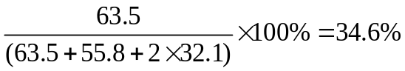
1b

Mass of ore = 100 g,
Mass of copper = 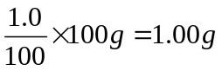

34.6% of chalcopyrite → 1.00 g copper
100% of ore → 2.89 g of chalcopyrite

1c(i)
2CuFeS₂ (s) + 3O₂ (g) → 2FeO (s) + 2CuS (s) + 2SO₂ (g)

1c(ii)
Amt of chalcopyrite = 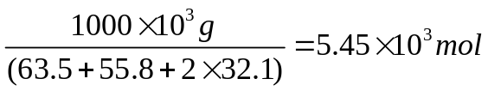
Amt of chalcopyrite = Amt of sulfur dioxide
Volume of sulfur dioxide =

2a(i)
Group VII

2a(ii)
Valence electron removed from Y must be from a higher energy principal quantum shell and experiences significant shielding effect by electrons in the inner shells that outweighs the increase in nuclear charge

OR increase in shielding effect outweighs increase in nuclear charge as there is an additional inner filled quantum shell of electrons in Y

effective nuclear charge decreases from X to Y hence less energy is required to remove the valence electron as compared to that of X.

2a(iii)
ZW₂

2b(i)
C²⁻ and D³⁻

2b(ii)

θ_{A} < θ_{B} < θ_{C} <θ_{D}
------ -

++++++ +

Source beams of ions

3a
∆H₄ represents lattice energy.
Lattice energy of an ionic compound is the energy released when one mole of the solid ionic compound is formed from its constituent gaseous ions under standard conditions.

3b(i)
By Hess’ Law, ∆H₁ = - ∆H₄ + 2∆H₂ + ∆H₃ = -(-1370) + 2(-132) + (-1099) = +7 kJ mol⁻¹

3b(ii)
E_{a}
(NH₄)₂SO₄(s)

2NH₄⁺(aq) + SO₄²⁻(aq)
energy
progress of reaction
∆H₁

3b(iii)
Amt of (NH₄)₂SO₄ used = 10.0/(132.1) = 0.0757 mol

Q=mc∆T
(∆H₁ x n) = (200)(4.0)( ∆T)
∆T = (7000x0.0757)/800 = 0.662 ºC

Temperature dropped by 0.662 ºC

3c
Lattice energy ∝ │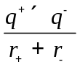│
The lattice energy of NH₄SeO₄ would be less exothermic compared to that of NH₄SO₄. This is because the SeO₄²⁻ ion has a bigger anionic radius compared to SO₄²⁻ ion, resulting in a lower charge density.

4a

NH₃(g) + HI(g) NH₄I(s)

K_{c}’ = _____1_____ = 1/(7.00x10⁻⁵) = 1.43 x 10⁴
[NH₃][HI]

4b

NH₃(g) + HI(g) NH₄I(s)
Amt 0.5 0.25 -
Eqm amt 0.5-x 0.25-x x
Eqm conc 0.5-x 0.25-x
10 10

K_{c}’ = _____1_____ __ = 1.43 x 10⁴
(0.5-x) (0.25-x)
10 10

(0.5-x)(0.25-x) = 0.006993
x² -0.75x + 0.118 = 0
x = 0.525 (rejected) or 0.225

Amt of NH₃ = (0.5-0.225) = 0.275 mol;
Amt of HI = (0.25-0.225) = 0.025 mol

4c
When the pressure is decreased at constant temperature, the concentrations of the gases decrease.

By Le Chatelier’s Principle, the system will try to increase the pressure by favouring the forward reaction to increase the number of moles of gases.

Hence the position of equilibrium will shift to the left and yield of ammonium iodide will decrease.

5a(i)
Structural isomerism or functional group isomerism

5a(ii)
The allyl alcohol cannot exhibit geometric isomerism.
This is due to the presence of 2 identical hydrogen atoms that are bonded to the same doubly-bonded carbon atom, thus the compound cannot show cis or trans isomers.

5a(iii)
Any one of the following tests is acceptable.

Acceptable distinguishing test | Observations
2,4-dinitrophenylhydrazine,  room temperature | Orange ppt observed for CH₃CH₂CHO.  No ppt observed for CH₂CHCH₂OH.
Tollens’ reagent, heat | Silver mirror observed for CH₃CH₂CHO.  No silver mirror observed for CH₂CHCH₂OH.
Fehling’s reagent, heat | Reddish brown ppt observed for CH₃CH₂CHO.  No reddish brown ppt observed for CH₂CHCH₂OH.
Na(s), room temperature | Effervescence of colourless gas that extinguishes lighted splint with ‘pop’ sound is observed for CH₂CHCH₂OH.  No effervescence and no gas evolved for CH₃CH₂CHO.
PCl₅, room temperature | Steamy white fumes that turns moist blue litmus red is observed for CH₂CHCH₂OH.  No steamy white fumes evolved for CH₃CH₂CHO.
Br₂(l) in CCl₄, room temperature | Reddish brown solution is decolourised for CH₂CHCH₂OH.  Reddish brown solution remains reddish brown for CH₃CH₂CHO.
Br₂(aq), room temperature | Yellowish orange solution is decolourised for CH₂CHCH₂OH.  Yellowish orange solution remains yellowish orange for CH₃CH₂CHO.

5b(i)

W | Z
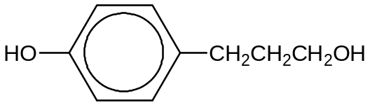 | 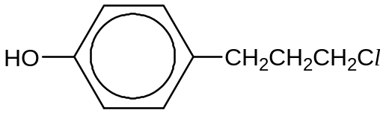
Y
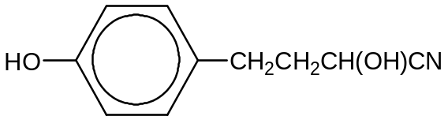

5b(ii)

Step 1: K₂Cr₂O₇, H₂SO₄(aq), heat with immediate distillation

Step 2: KMnO₄, H₂SO₄(aq), heat

B6

6a(i)
The pH of a solution is a measure of acidity or alkalinity of the solution. It is the negative logarithm to base ten of the hydrogen ion concentration in mol dm^{–3} i.e. pH = – lg [H⁺(aq)]
6a(ii)
Acid is H₂CO₃, conjugate base is HCO₃⁻

6a(iii)
HCO₃⁻ + H⁺ → H₂CO₃

6a(iv)

K_{a} = [H⁺]² / [H₂CO₃] => [H⁺] = (K_{a} [H₂CO₃])^{1/2} = (7.95 x 10⁻⁷ x 0.10) ^{1/2}

= 2.82 x 10⁻⁴ mol dm⁻³
pH = 3.55

6a(v)
Amt of carbonic acid used = 25/1000 x 0.10 =2.50 x 10⁻³ mol
Amt of NaOH(aq) = 30/1000 x 0.60 = 0.018 mol

NaOH(aq) is in excess.

[OH-] in excess = (0.018-2.50 x 10⁻³ )/ 55/1000 = 0.281 mol dm⁻³

pH = 13.4

6a(vi)

Phenolphthalein

6a(vii)
Carbonic acid is a weak acid as [H⁺] is not equal to [carbonic acid]. Thus carbonic acid did not fully dissociate to give H⁺ ions.

6b(i)
NaCl dissolves (hydrates) readily in water to form aquated ions and neutral solutions of pH 7.

NaCl(s) + aq → Na⁺(aq) + Cl⁻(aq)

AlCl₃ dissolves in water to form acidic solutions (due to the very high charge density of Al³⁺). The small, highly polarising cation weakens the O–H bonds of the water molecules in its surrounding sphere of coordination and results in the release of hydrogen ions in solution. pH of the resulting solution is about 3.

AlCl₃(s) + 6H₂O(l) → [Al(H₂O)₆]³⁺(aq) + 3Cl–(aq) (3)
[Al(H₂O)₆]³⁺(aq) + H₂O(l)[Al(H₂O)₅(OH)]²⁺(aq) + H₃O⁺(aq) (4)

6b(ii)
I : BeO + 2OH⁻ + H₂O → [Be(OH)₄]²⁻

II: BeO + 2H⁺ → Be²⁺ + H₂O

6b(iii)
MgO(s) + H₂O(l) Mg(OH)₂(s)
MgO is sparing soluble in water as MgO has a very exothermic lattice energy.

MgCl₂(s) + 6H₂O(l) → [Mg(H₂O)₆]²⁺(aq) + 2Cl–(aq) (1)
[Mg(H₂O)₆]²⁺(aq) + H₂O(l)[Mg(H₂O)₅(OH)]⁺(aq) + H₃O⁺(aq) (2)
Due to the high charge density of Mg²⁺ , it polarises the water molecules to a slight extent. MgCl₂ undergoes slight hydrolysis to give a weakly acidic solution.

The acidic solution formed reacts with MgO, thus dissolving it.
MgO(s) + 2H⁺(aq) → Mg²⁺(aq) + H₂O(l)

6c

Amount of XCl_{n} = 100/1000 x 0.400 = 0.0400 mol

Amt of XCl_{n} : Cl⁻ = 0.0100 : 0.0400 = 1 : 4

X is in Group IV.
B7a

B7a(i) Explanations and equations
P, C₅H₉ClO₂ | C to H ratio is not close to 1:1, W does not contain an aromatic ring.
P sparingly soluble in water but soluble in NaOH | P has –COOH group and a large hydrophobic group.
Heating P in aq NaOH and adding excess acid to the product produces Q, C₅H₁₀O₃. | Nucleophilic substitution  Q which will have an alcohol group on it.  Or eqn
Q reacts with warm aqueous alkaline iodine to give a yellow ppt | Q has CH₃CH(OH)- group.  Or eqn
Q forms 2 isomers, R, S and T, C₅H₈O₂ when it is refluxed with conc sulfuric acid. | Q undergoes dehydration/elimination to give  S which has a C=C double bond.  Or eqn
S and T can exhibit cis-trans isomerism. | S and T each has a C=C double bond with 2 different substituents on each C of the double bond.
S reacts with aq Br₂ to give a number of products one of which is  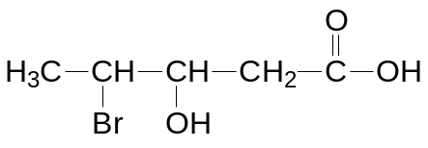 | S undergoes addition reaction.
S undergoes reaction with acidified potassium manganate (VII) to give U, C₃H₄O₄ and ethanoic acid. | Strong oxidation. The C=C double bond is cleaved and is located between the 2nd and 3rd carbon in the carbon chain of S.  Or eqn
1 mol U reacts with excess with excess Na₂CO₃ to give 1 mole of CO₂ | U is a dicarboxylic acid.  Or eqn
R is a sweet smelling liquid. | Q undergoes self-esterification to form ester R. Or eqn

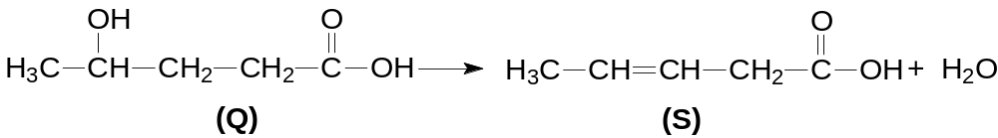

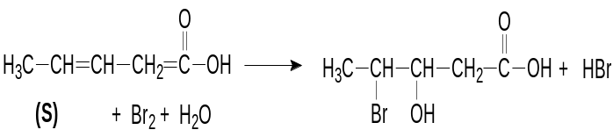
Br₂ + H₂O

(S)
(U)

(U)

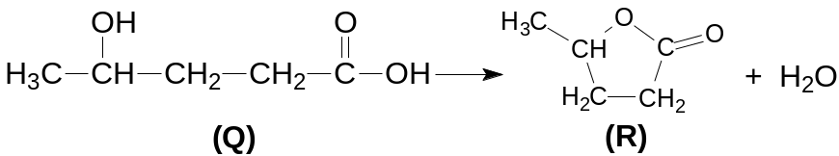

Structures

P: 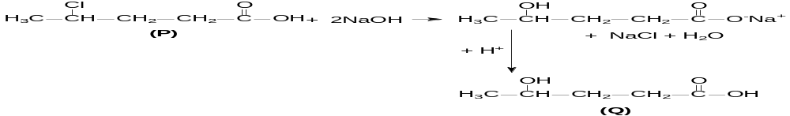 Q:

R: S/T:

U:

B7a(ii)

B7a(iii)

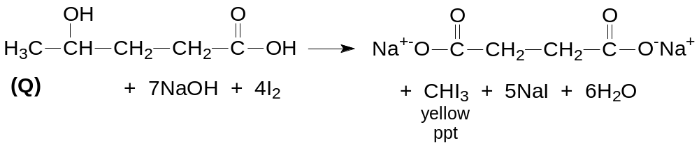

7b(i)
Compare expt 1 and 3, when [propanone] tripled, the initial rate increased by 3x ⇒ first order reaction with respect to propanone.

Compare expt 1 and 2, when [H⁺] doubled, the initial rate increased by 2x ⇒ first order reaction with respect to H⁺.

Compare expt 3 and 4, when [H⁺] and [I₂] doubled, the rate increased by 2x ⇒zero order reaction with respect to iodine.

Order of reaction with respect to
Propanone = 1; acid = 1; iodine =0

7b(ii)
Using Expt 1:
Rate = k[propanone] [H⁺]
  - x 10⁻⁴ = k(0.4)(0.4)
k = 6.31 x 10⁻⁴ mol⁻¹dm³min⁻¹

7b(iii)
number of molecules with a given energy
kinetic energy
E_{a}
0
T₁
T₂
total no. of molecules with energy
E_{a} at temperature T₁
total no. of molecules with energy
E_{a} at temperature T₂
T₂ > T₁

The shaded area under the Maxwell-Boltzmann distribution curve is proportional to the number of molecules possessing energy greater than or equal to the activation energy, E_{a}.
When temperature decreases (from T₂ to T₁), the number of reacting molecules possessing energy greater than or equal to the activation energy decreases.
The frequency of effective collisions decreases. Hence, the rate of reaction decreases.

B8(a)

Explanations:
W, C₆H₈O | W is not a saturated compound.
W reacts with excess hydrogen in presence of nickel catalyst to give X, C₆H₁₂O | W is reduced to X.  Or eqn
X reacts with sodium metal to give H₂(g) | X contains an alcohol functional group.  Or eqn
W gives an orange ppt with 2,4-DNPH | Condensation / Addition-elimination reaction  W must be an aldehyde or ketone.  Or eqn
W does not react with Tollens’ Reagent | W is not an aldehyde. W is likely to be a ketone.
W decolourised reddish-brown bromine and formed Y, C₆H₈Br₂O. | W undergoes addition to form Y. W is an alkene.  Or eqn
With HCN, W forms compound Z, C₇H₉NO. | W undergoes addition to form Z.  Or eqn

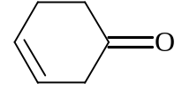
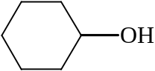
+ 2H₂ →

W
X

+ Na → 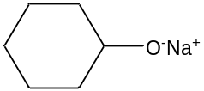 + ½ H₂
X

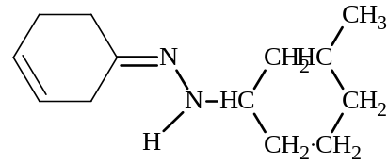
NO₂
NO₂
+ 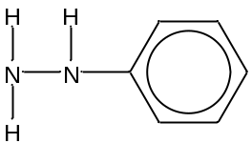 → + H₂O
W

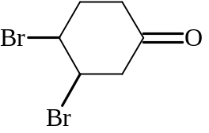
+ Br₂ →

W
Y

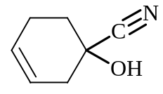
+ HCN →

W
Z
Structures
W: Y:
cyclohex-3-en-1-one

X : Z:

8b(i)
C- Cl bond is the weakest.
Cl has the largest atomic orbital, the valence orbital used in bonding is larger and more diffuse so that the overlap of the C- Cl orbitals is least effective, hence C- Cl bond length is the longest/C-Cl bond energy is the smallest

8b(ii)
CHFClCF₃ has a lower boiling point than CClF₂CF₂CHClF.
CHFClCF₃ has a smaller and less polarisable electron cloud, thus it has weaker van der Waals’ forces of attraction between the molecules. Less energy is required to overcome these weaker interactions and thus CHFClCF₃ has a lower boiling point.

8c(i)

shape: bent Bond angle: ≈104.5⁰

8c(ii)
Chlorine dioxide has an unpaired electron thus it has a tendency to take in electrons to achieve a stable electronic structure.

8c(iii)
Lone pair of electrons on oxygen in chlorine dioxide is able to undergo H-bonding with water.

